Bias Voltage for Current Conditioning
What should be happening:
- The difference between the 2 outputs should match the input signal

Purpose of Fully differential Op-Amp
- To get the input single ended signal to become a differential signal.
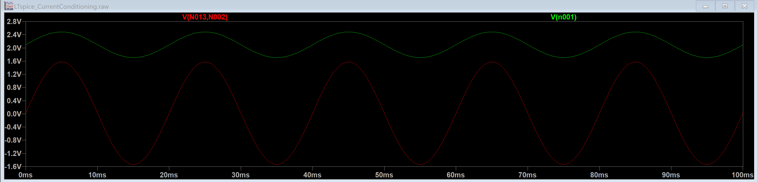
Green curve: the input + terminal of the fully differential op amp – the single ended signal that we want to make differential
- Characteristics about the signal:
  - It is biased by 1.67V by the external voltage source in the inverter

Red curve: the difference between the 2 outputs of the fully differential op amp
- Should in theory

https://www.analog.com/en/resources/technical-articles/precision-fully-differential-op-amp-drives-high-resolution-adc-at-low-power.html

